Bhakti B. Sonule

**ShopNext E-Commerce Market Analysis**

**Contents**

**1. Key Performance Indicators (KPIs):** 2

Total Sales (₹16M) 2

Total Orders (1,00,000) 2

Profit Margin (29%) 2

Delayed Deliveries (8,715) vs. On-Time Deliveries (1,03,935) 2

Average Payment Value (₹154) 2

**2. Active Sellers by Month (Key Observation: Seller Activity Drop)** 2

February (Approx. 4,000 sellers) 2

March onward (near zero sellers) 3

Immediate Action Needed 3

**3. Payment Type Distribution** 3

Credit Card (73.92%) 3

Boleto (19.04%) 3

Voucher (5.56%) 3

**4. Delivery Type by Year and Month (Stable On-Time Deliveries)** 3

Suggestion 3

**5. Product Category Breakdown** 4

Top 10 Product Categories (by Total Orders) 4

18 Bottom Product Categories 4

Recommendation 4

**6. Product-wise Profit Margins** 4

**7. Month-wise Payment Value (Declining Trend)** 4

Key Concerns 5

**8. Customer Feedback (Rating Breakdown)** 5

Excellent Ratings (57k orders) 5

Very Good (19k) and Good (8k) 5

Bad (3k orders) and Very Bad (12k orders) 5

Strategic Recommendations 5

# **1. Key Performance Indicators (KPIs):**

## Total Sales (₹16M)

This figure represents the total revenue generated by ShopNest from all orders. Although the overall revenue is substantial, it's important to evaluate if this is on target compared to historical data or future goals.

## Total Orders (1,00,000)

ShopNest has successfully processed a significant number of orders. The volume suggests a solid customer base and healthy transaction activity. However, analyzing average order value (AOV) can give further insights into customer spending habits, which seems to be ₹160/order

(₹16M/1,00,000).

## Profit Margin (29%)

This is a critical metric for evaluating business sustainability. A 29% margin indicates that ShopNest is generating decent profits, but the margin varies significantly across different product categories (as seen in the product-wise profit margin breakdown). Further optimization could focus on categories with higher margins.

## Delayed Deliveries (8,715) vs. On-Time Deliveries (1,03,935)

ShopNest maintains a high standard of delivery performance, with 91.3% of orders delivered on time. However, 8,715 delayed deliveries account for approximately 8.7% of total orders, which is an area for potential process improvement. Identifying root causes such as supply chain issues, vendor delays, or logistics bottlenecks will help minimize this number.

## Average Payment Value (₹154)

This relatively low average value indicates that the majority of orders might consist of lower-value items. This metric should be compared with industry benchmarks to understand if it reflects the right pricing strategy or if there’s room for increasing basket size (e.g., through cross-selling or up-selling).

# **2. Active Sellers by Month (Key Observation: Seller Activity Drop)**

## February (Approx. 4,000 sellers)

February shows a peak in seller activity, which is likely due to some promotional event or seasonality (e.g., sales campaigns).

## March onward (near zero sellers)

There is a sudden drop to nearly 0 active sellers from March onwards, continuing through April. This is a significant red flag, and you may need to explore reasons behind this, such as:

1. Platform issues (technical difficulties, dissatisfaction with the interface or policies).
2. Economic factors or global events (e.g., COVID-19 disruptions).
3. Seller migration to competitors or a lack of incentives to continue selling.

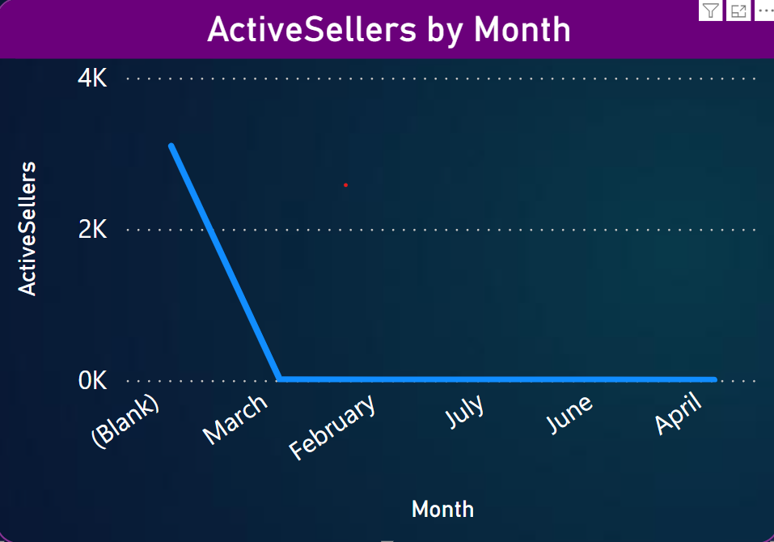

## Immediate Action Needed

Investigate seller grievances, platform changes, or external conditions that led to the drop. Consider rolling out seller retention programs or incentives to re-engage inactive sellers.

# **3. Payment Type Distribution**

## Credit Card (73.92%)

With 76.8k orders paid via credit card, this remains the dominant payment method. This may suggest that the platform caters predominantly to consumers who prefer or are eligible for credit-based payments, and this can help target future promotions.

## Boleto (19.04%)

The Boleto payment method (used primarily in Brazil) is also significantly popular, representing 19.78k orders. It suggests a large user base from regions where this payment method is common. Consider focusing marketing efforts in regions that rely on Boleto for transactions.

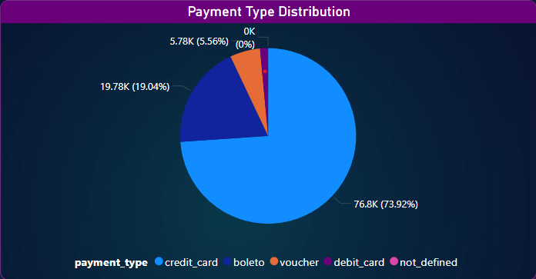

## Voucher (5.56%)

Vouchers indicate promotional efforts or loyalty programs, showing 5.78k orders. You could investigate how effective the current promotions are and see if this method can be expanded to attract more customers.

# **4. Delivery Type by Year and Month (Stable On-Time Deliveries)**

- The graph shows consistency in on-time deliveries, even as sales volume fluctuates across months.

- Delayed deliveries remain a minor issue, but there is a noticeable uptick in delays around May 2017 and June 2018. Investigating the causes for these deviations (e.g., logistics, seasonal rushes) can further reduce delivery delays.

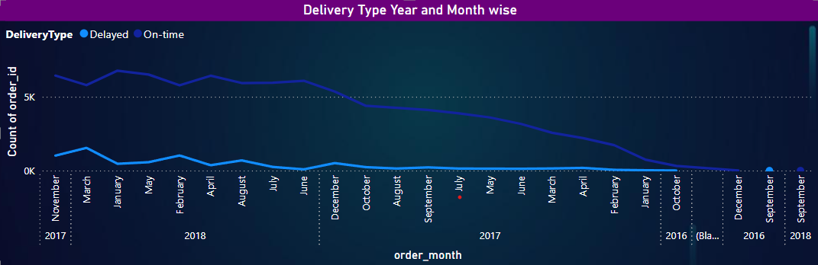

## Suggestion

Conduct a deeper analysis of logistics data during these months to pinpoint bottlenecks. You may also want to review regional logistics partners for performance discrepancies.

# **5. Product Category Breakdown**

## Top 10 Product Categories (by Total Orders)

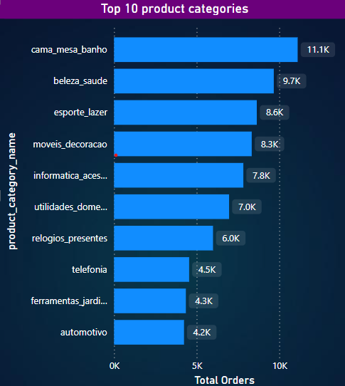

**Cama Mesa Banho (11.1k orders):** This category (home linens and bedding) is the top-performing one, suggesting strong customer demand in home improvement products.

**Beleza Saude (9.7k orders):** Health and beauty products also perform exceptionally well, indicating a lucrative niche.

**Esporte Lazer (8.6k orders):** Sports and leisure products rank third, reflecting growing consumer interest in lifestyle and fitness.

These three categories are ShopNest’s powerhouses and warrant special focus for inventory management, marketing, and promotions.

## 18 Bottom Product Categories

Products like Cine Foto (72 orders), DVDs Blu-Ray (64 orders), and Musica (38 orders) are among the lowest-performing categories. These categories may suffer from:

1. Obsolete product types (e.g., DVDs, Blu-ray due to digital streaming).
2. Lower consumer interest in specific niche items.

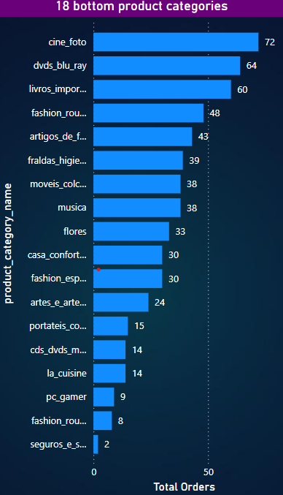

## Recommendation

- Retiring these categories to focus on high-performing products.

- Creating niche-targeted campaigns to stimulate sales for these underperforming categories.

# **6. Product-wise Profit Margins**

1. Utilidades Domesticas and Tablets Impressao Imagem boast high-profit margins of nearly 99%, suggesting that these categories are popular and highly profitable.
2. Telefonia Fixa (99.66%) and Telefonica (98.42%) have similarly high margins, making telecommunications equipment a strong contributor to overall profit.

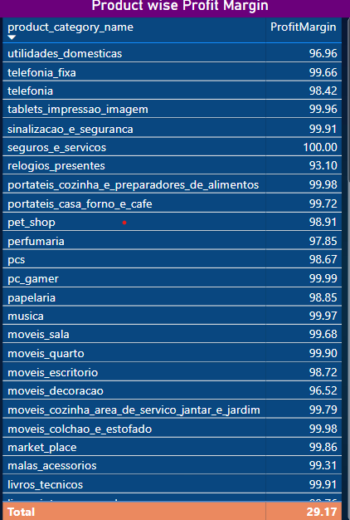

Actionable Insight: Focus on these high-margin categories when planning sales campaigns or bundle deals to boost overall profitability.

# **7. Month-wise Payment Value (Declining Trend)**

1. The overall payment value appears to be declining month-on-month, which may indicate a shrinking AOV or fewer high-value transactions.

## Key Concerns

1. Is this due to changing consumer behavior (e.g., customers buying cheaper items)?
2. Is this due to market saturation or competition

- Explore customer segmentation to identify if specific customer types are responsible for the declining trend and target them with personalized promotions or loyalty programs.

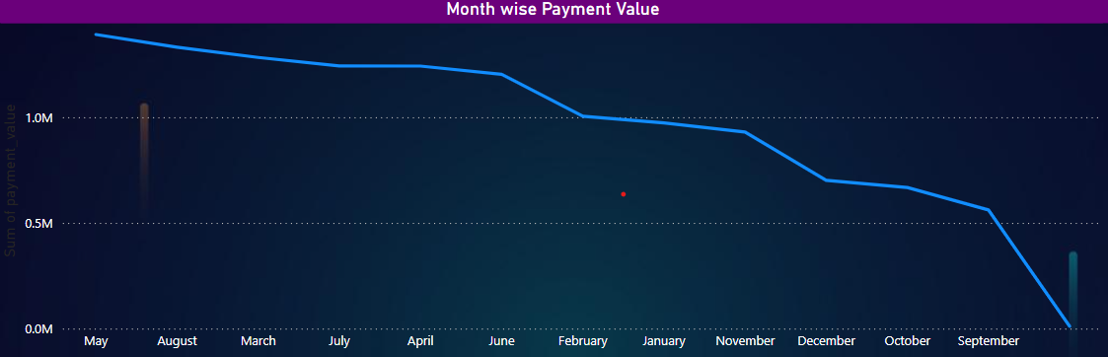

# **8. Customer Feedback (Rating Breakdown)**

## Excellent Ratings (57k orders)

Customer satisfaction is overwhelmingly positive, with 57% of orders rated as "Excellent". This is a strong indicator that the platform is delivering on customer expectations in key areas like product quality and delivery times.

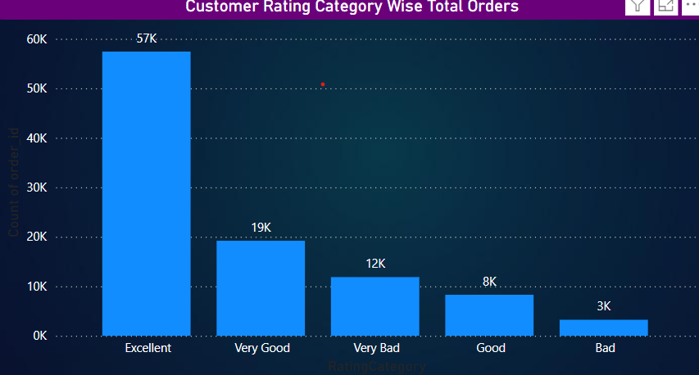

## Very Good (19k) and Good (8k)

A significant portion of the customer base is satisfied, but there’s room for improvement. Understanding the nuances of feedback (perhaps through NPS scores or detailed reviews) could highlight specific areas for improvement.

## Bad (3k orders) and Very Bad (12k orders)

Around 15k orders received negative ratings. Investigate these cases, possibly through direct follow-ups, to identify common issues and prevent further dissatisfaction.

## Strategic Recommendations

**1. Seller Engagement:** Urgently address the sharp decline in active sellers from March onwards. This could involve seller surveys, incentives, or streamlined processes to bring sellers back.

**2. Product Categories:**

- Focus marketing efforts on high-margin categories like Utilidades Domesticas and Telefonia.

- Consider retiring low-demand categories like DVDs Blu-ray unless niche demand can be stimulated.

**3. Customer Satisfaction:**

- Although most ratings are excellent, focus on resolving the issues behind the Bad and Very Bad ratings to improve customer retention.

**4. Delivery Efficiency:**

- While on-time delivery performance is solid, addressing the causes of delays, especially around peak months (May-June), could further enhance customer satisfaction.

**5. Boost AOV:**

- With a declining month-wise payment value, consider upselling/cross-sell strategies or promotional bundling to increase average basket size.

This dashboard provides a great foundation for performance tracking. It highlights key areas for improvement, especially in seller engagement and declining payment values, while showcasing strengths in customer satisfaction and profitability.